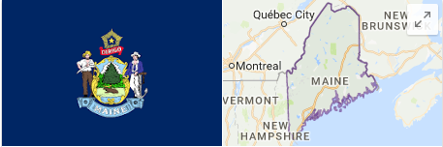**State of Maine**

**Engy Fouda**

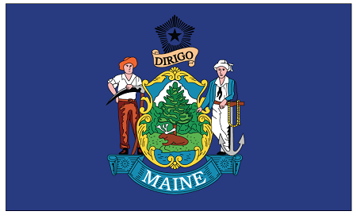

# Abstract

# Introduction

Predicting the outcome of 2020 presidential elections in Maine needs scrutinizing multiple aspects that can affect the voters’ opinions. In 2016, Maine changed from hard core democrat state to lean democrat state. After my research, I think that many counties chose to be republican because all counties chose Sanders and not Clinton. Probably, if the democrat party nominated another candidate in the next elections, Maine will choose the new candidate over the republican one.

# 1. Defining the 5 major categories and how they relate to voters’ outcome to include GDP

**Maine Economic indicators**

According to a [study on Maine economy done the University of Maine](http://umaine.edu/soe/files/2016/02/OverviewMEEcon2016.pdf) in February 2016

1. Real Gross Domestic Product: Increased 1.0% in the second quarter of 2015
2. Personal Income: Grew 3.5% in the first three quarters of 2015
3. Wage and Salary Income: Grew over 3.3% in the first three quarters of 2015
4. Employment: Maine has recovered about 23,000 jobs since 2008
5. Unemployment: Unemployment rate is now about 4%; down from over 8%.

## **Maine GDP**

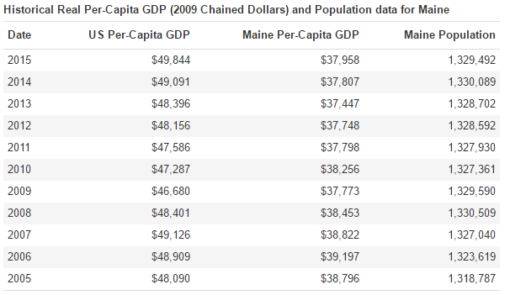

Source: <http://www.deptofnumbers.com/gdp/maine/>

**Factors affecting Maine Economy**

According to [Portland Press Herald](http://www.pressherald.com/2016/06/14/maine-gdp-grew-1-3-percent-in-4th-quarter/) and Maine’s revenue datasets provided on Maine.gov website (<https://data.maine.gov/browse?category=Finances&utf8=%E2%9C%93>), Professional, scientific and technical services.

1.Agriculture 2.Forestry 3. Fishing 4.Hunting 5.Taxes   
6.Management of companies and enterprises   
7.The finance and insurance sector

**In Graph the total GDP for Maine**

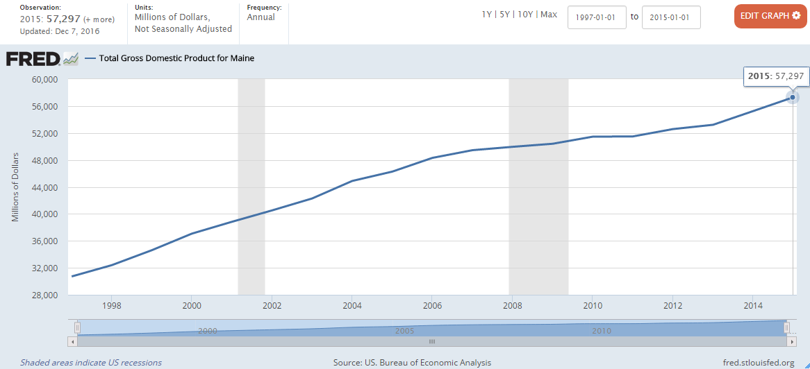

Source: <https://fred.stlouisfed.org/series/MENGSP>

**Percentage change in US-GDP by State, Maine scored 0.6%**

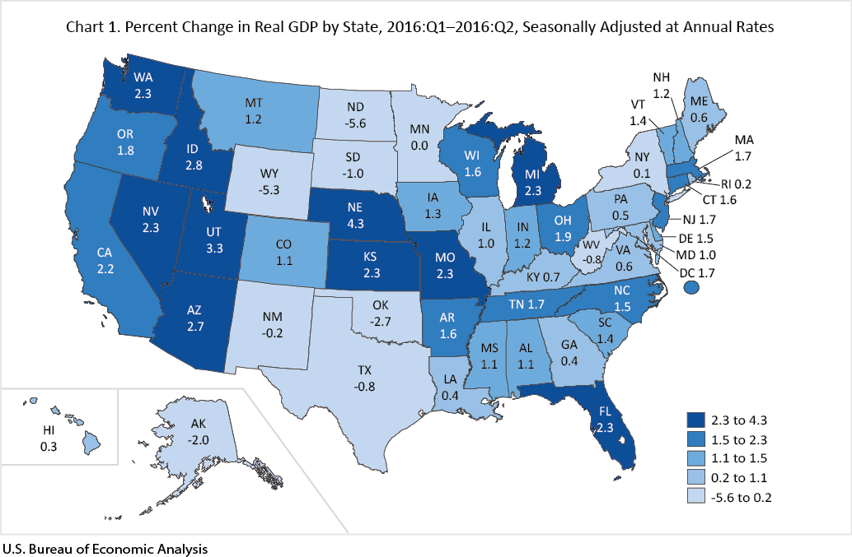

Source: <http://www.bea.gov/newsreleases/regional/gdp_state/qgsp_newsrelease.htm>

**Unemployment rate in Maine**

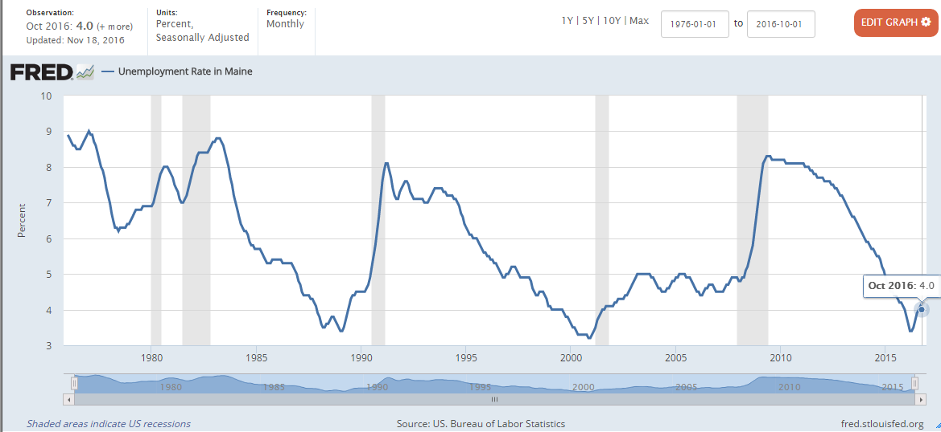

Source:<https://fred.stlouisfed.org/series/MEUR?utm_source=series_page&utm_medium=related_content&utm_term=related_resources&utm_campaign=categories>

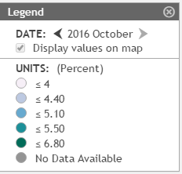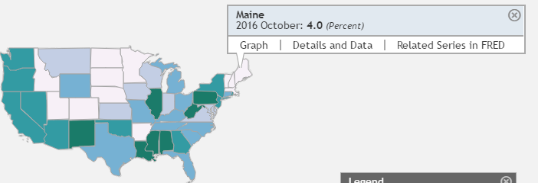**Comparing the unemployment rate of Maine to the rest of the states**

Source: <https://geofred.stlouisfed.org/map/?th=pubugn&cc=5&rc=false&im=fractile&lng=-99.67&lat=26.59&zm=3&sl&sv&sti=1224&rt=state&at=Seasonally%20Adjusted,%20Monthly,%20Percent&fq=Monthly&am=Average&un=lin&dt=2016-10-01>

## **Median Income for Maine**

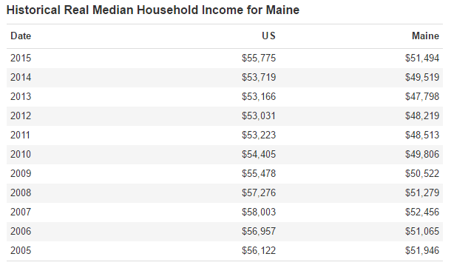

Source: <http://www.deptofnumbers.com/income/maine/>

## **Income forecast for Maine**

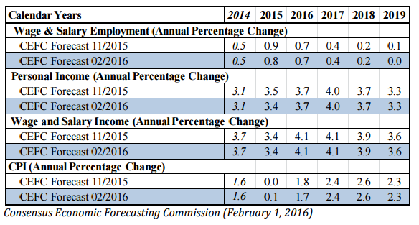

Source: <http://umaine.edu/soe/files/2016/02/OverviewMEEcon2016.pdf>

**How exit polls showed the income factor in 2016 election in Maine**

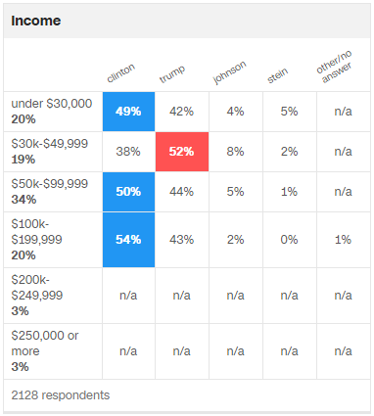

Source: <http://www.cnn.com/election/results/exit-polls/maine/president>

**Arranging the Pew Research Center issues for Maine  
(http://www.people-press.org/2016/07/07/4-top-voting-issues-in-2016-election/)**

1. Economy
2. Education
3. Environment
4. Health care
5. Gun control
6. Trade policy
7. Social security
8. Abortion
9. Treatment of gay, lesbian, transgender people
10. Foreign policy
11. Supreme court appts
12. Terrorism
13. Immigration
14. Treatment of racial, ethnic minorities

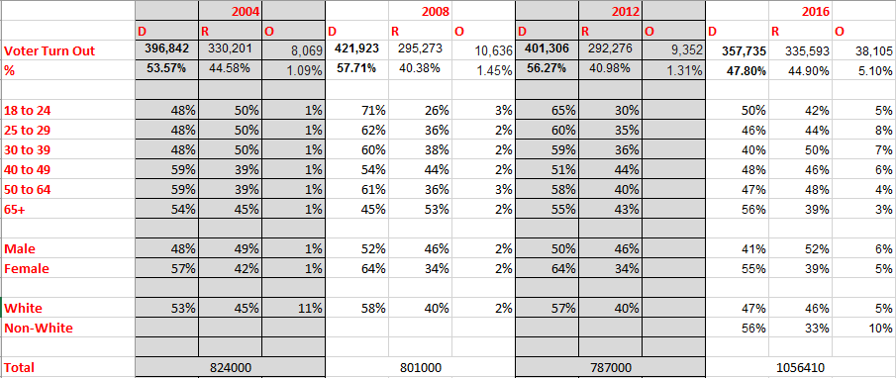2. Defining the 3 major groups and how they relate to voters’ outcome

3. Determining best-fit model based on state and the party that will win that election

The likelihood probability for Maine that the democrat will win 2020 by a minor difference of about +3% than the republicans where the historical data from 1960 to 2016 shows that the mean percentage of Democrats is about 43% while the mean percentage of the Republicans in Maine is 40%. It is the same difference between the Democrats and Republicans in 2016 in Maine.   
(More details will be explained in Q.4 where it shows the summary of the historical data output from the R-studio).

In 2016, three electoral votes went to Clinton versus only one electoral vote went to Trump.4. Reviewing past elections to see if there are any predictable outcomes (patterns)

Maine is “Lean Democrat” because Democrat won 7 out of 15 times from 1960 till 2016. Predicting that it will mostly vote Democrat in 2020 with a small difference. Starting from 1992, Democrat won straight in Maine.

|  |  |  |  |  |
| --- | --- | --- | --- | --- |
| Year | D | % | R | % |
| 2016 | **357,735** | **47.80%** | 335,593 | 44.90% |
| 2012 | **401,306** | **56.27%** | 292,276 | 40.98% |
| 2008 | **421,923** | **57.71%** | 295,273 | 40.38% |
| 2004 | **396,842** | **53.57%** | 330,201 | 44.58% |
| 2000 | **319,951** | **49.10%** | 286,616 | 44.00% |
| 1996 | **312,788** | **51.60%** | 186,378 | 30.80% |
| 1992 | **263,420** | **38.80%** | 206,820 | 30.40% |
| 1988 | 243,569 | 43.90% | **307,131** | **55.30%** |
| 1984 | 214,515 | 38.80% | **336,500** | **60.80%** |
| 1980 | 220,974 | 42.30% | **238,522** | **45.60%** |
| 1976 | 232,279 | 48.07% | **236,320** | **48.91%** |
| 1972 | 160,584 | 38.50% | **256,458** | **61.50%** |
| 1968 | **217,312** | **55.30%** | 169,254 | 43.10% |
| 1964 | **62,264** | **68.84%** | 118,701 | 31.16% |
| 1960 | **181,159** | **42.95%** | 240,608 | 57.05% |

**In R**

> summary(MyData);

Year D D_percentage R R_percentage

Min. :1960 160,584:1 38.80% :2 118,701:1 30.40% :1

1st Qu.:1974 181,159:1 38.50% :1 169,254:1 30.80% :1

Median :1988 214,515:1 42.30% :1 186,378:1 31.16% :1

Mean :1988 217,312:1 42.95% :1 206,820:1 40.38% :1

3rd Qu.:2002 220,974:1 43.90% :1 236,320:1 40.98% :1

Max. :2016 232,279:1 47.80% :1 238,522:1 43.10% :1

(Other):9 (Other):8 (Other):9 (Other):9

The difference between the Demarcate mean and Republicans mean is not that much!

5. Defining 2016 Elections Polls - who was right? Name 3 Gallup polls that support your prediction

<http://projects.fivethirtyeight.com/2016-election-forecast/maine/>

<http://www.nytimes.com/interactive/2016/upshot/maine-election-forecast.html>

<http://www.governing.com/topics/elections/gov-electoral-college-handicapping-october-2016.html>

They all predicted that Democrats will win Maine in 2016, and this what happened. Clinton won 3 electoral votes out of the 4 votes of Maine with popular vote of 48% while Trump was 45% and Johnson was 5%. Moreover, Maine caucus counties voted for Sanders and none voted for Clinton. On the other hand, Ted Cruz won 15 out of 16 counties in Maine and Trump won only one county.

6. Providing valid research or sources on which you are basing your data sets on

<https://en.wikipedia.org/wiki/United_States_presidential_election_in_Maine,_2016>

<https://en.wikipedia.org/wiki/United_States_presidential_election_in_Maine,_2012>

<https://en.wikipedia.org/wiki/United_States_presidential_election_in_Maine,_2004>

<https://en.wikipedia.org/wiki/United_States_presidential_election_in_Maine,_2000>

<https://en.wikipedia.org/wiki/United_States_presidential_election_in_Maine,_1996>

<https://en.wikipedia.org/wiki/United_States_presidential_election_in_Maine,_1992>

<https://en.wikipedia.org/wiki/United_States_presidential_election_in_Maine,_1988>

<https://en.wikipedia.org/wiki/United_States_presidential_election,_1984>

<https://en.wikipedia.org/wiki/United_States_presidential_election_in_Maine,_1984>

<https://en.wikipedia.org/wiki/United_States_presidential_election_in_Maine,_1980>

<https://en.wikipedia.org/wiki/United_States_presidential_election_in_Maine,_1976>

<https://en.wikipedia.org/wiki/United_States_presidential_election_in_Maine,_1972>

<https://en.wikipedia.org/wiki/United_States_presidential_election_in_Maine,_1968>

<https://en.wikipedia.org/wiki/United_States_presidential_election,_1964>

<https://en.wikipedia.org/wiki/United_States_presidential_election,_1960>

<http://www.cnn.com/election/results/exit-polls/maine/president>

<http://www.cnn.com/election/2012/results/state/ME/president/>

<http://www.cnn.com/ELECTION/2008/results/polls/#MEP00p1>

<http://www.cnn.com/ELECTION/2004/pages/results/states/ME/P/00/epolls.0.html>

<http://bowdoinorient.com/article/503>

7. Defining demographics and voting patterns (2000 to 2016)

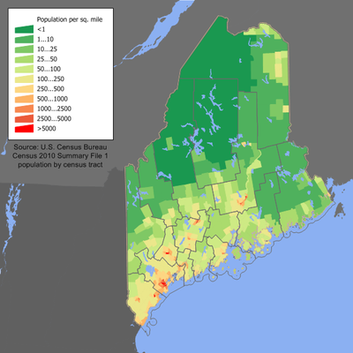

Maine population density map. Source: <https://en.wikipedia.org/wiki/Maine>

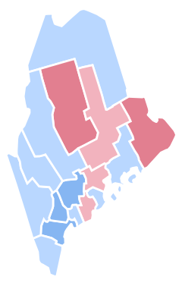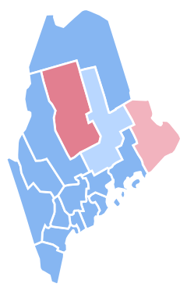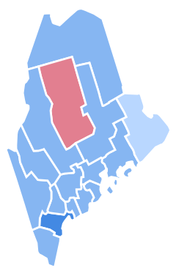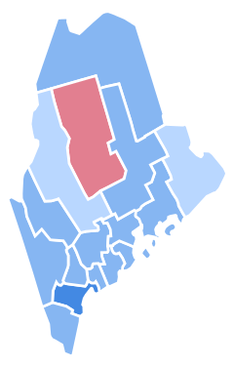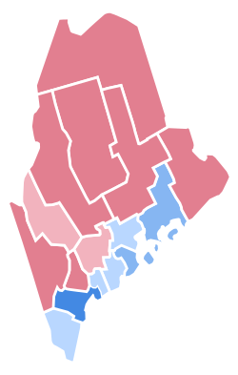

Republic

Democrat

2000 2004 2008 2012 2016

Where

**Using Monte Carlo and county data from 1996 to 2016 to predict 2020**

It is close and on the edge prediction. The outcome is that Democrat can win by 50.8% only!

The sources are: <http://uselectionatlas.org/RESULTS/state.php?year=2016&fips=23&f=0&off=0&elect=0>

<http://www.politico.com/2012-election/results/president/maine/><http://uselectionatlas.org/RESULTS/state.php?f=0&fips=23&year=2008><http://uselectionatlas.org/RESULTS/state.php?f=0&fips=23&year=2004>

<http://uselectionatlas.org/RESULTS/datagraph.php?fips=23&year=2004&off=0&elect=0&f=0><http://uselectionatlas.org/RESULTS/datagraph.php?fips=23&year=2000&off=0&elect=0&f=0>

**The UNIVARIATE Procedure**

**Variable: SampleMean (Sample Mean of U(0,1) Data)**

| **Moments** | | | |
| --- | --- | --- | --- |
| **N** | 16 | **Sum Weights** | 16 |
| **Mean** | 0.50820313 | **Sum Observations** | 8.13125 |
| **Std Deviation** | 0.03322744 | **Variance** | 0.00110406 |
| **Skewness** | 0.065602 | **Kurtosis** | 0.37831767 |
| **Uncorrected SS** | 4.14888761 | **Corrected SS** | 0.01656095 |
| **Coeff Variation** | 6.53822114 | **Std Error Mean** | 0.00830686 |

**The UNIVARIATE Procedure**

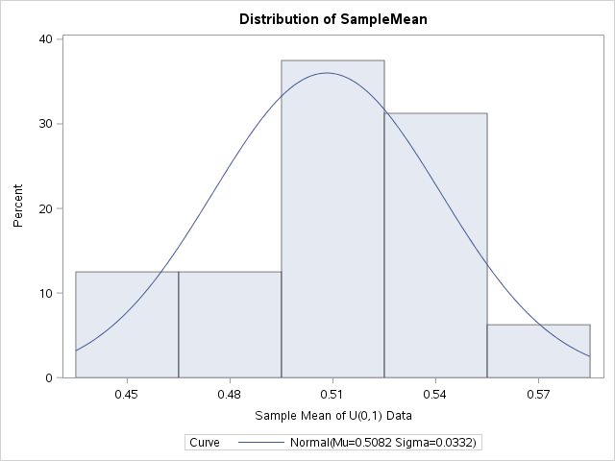

8. Create a data set to store your Big Data and run the appropriate statistical analyses

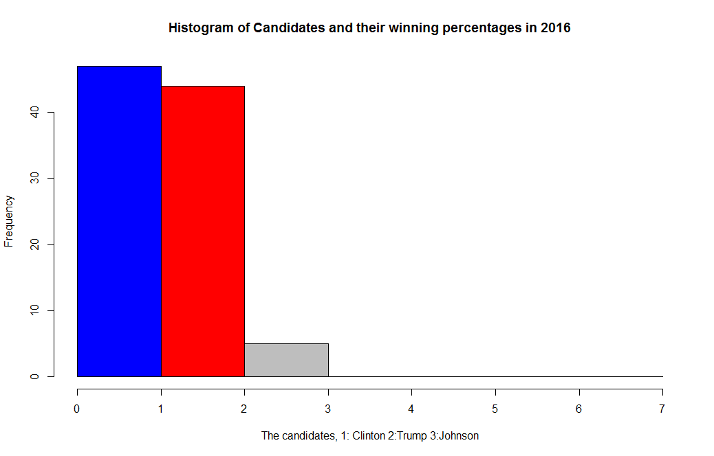

**Single proportion hypothesis**

**The R code:**

# Based on the historical data of Maine: http://www.270towin.com/states/Maine

#Since 1960, Republicans won 6 times out of 15 times, and Democratic won 9 times

#My Null Hypothesis will be Republicans win in 2020

#It is a 2-tailed Hypothesis

#H0: R wins

#Ha: R loses

>prop.test(6, 15)

1-sample proportions test with continuity correction

data: 6 out of 15, null probability 0.5

**The Analysis of the output:**

H0: R wins

Ha: R loses

Can’t reject the Null Hypothesis as p-value > 0.5.

Can’t reject that Republican can win the election in Maine in 2020!

X-squared = 0.26667, df = 1, p-value = 0.6056

alternative hypothesis: true p is not equal to 0.5

95 percent confidence interval:

0.1745677 0.6710894

sample estimates:

p

0.4

**T-Test**

#Again running the Null Hypothesis as Republican will win by

#collecting the Republican votes in the elections from 2016 till 1988

> RepVote=c(335593,292276,295273,330201,286616,186378,206504,307131,336500,238522,236320,256458,169254,118701,240608)

> t.test(RepVote)

One Sample t-test

data: RepVote

t = 15.216, df = 14, p-value = 4.213e-10

alternative hypothesis: true mean is not equal to 0

95 percent confidence interval:

219704.2 291807.1

sample estimates:

mean of x

**The Analysis of the output:**

H0: R wins

Ha: R loses

Can reject the Null Hypothesis as p-value < 0.5.

Can reject that Republican will win the election in Maine in 2020!

255755.7

>

> # Two-sided t-test

> t.test(RepVote, alternative = "two.sided")

One Sample t-test

data: RepVote

t = 15.216, df = 14, p-value = 4.213e-10

alternative hypothesis: true mean is not equal to 0

95 percent confidence interval:

219704.2 291807.1

sample estimates:

mean of x

255755.7

**Chi-Square Test**

> MaineVoters2020=matrix(c(335593,357735,38105),ncol=3)

> colnames(MaineVoters2020) <-c("R","D","others")

> MaineVoters2020 <- as.table(MaineVoters2020)

> round(prop.table(MaineVoters2020), 2) # Show as proportions w/2 digits

R D others

A 0.46 0.49 0.05

>

> chi1 <- chisq.test(MaineVoters2020) # Save tests as object "chi1"

> chi1 # Check results

Chi-squared test for given probabilities

data: MaineVoters2020

X-squared = 261340, df = 2, p-value < 2.2e-16

>

> #compare it with 2016 percentages

> chi2 <- chisq.test(MaineVoters2020, p = c(0.449,0.478,0.073))

> chi2

Chi-squared test for given probabilities

data: MaineVoters2020

X-squared = 4723.3, df = 2, p-value < 2.2e-16

**Scatter plot of the counties and parties**

> counties=c("Androscoggin","Aroostook","Cumberland","Franklin","Hancock","Kennebec","Knox","Lincoln","Oxford","Penobscot","Piscataquis","Sagadahoc","Somerset","Waldo","Washington","York");

> Democrate=c(22975,13377,102935,7001,16107,31753,12440,10241,16214,32832,3098,10679,9092,10442,6358,55828)

> Republican=c(28189,19419,57697,7900,13682,29296,9148,9727,12172,41601,5403,9304,14998,10378,9037,50388)

> MaineCounties=data.frame(Democrate,Republican,count = c(1:16));

> counties1=c(1,2,3,4,5,6,7,8,9,10,11,12,13,14,15,16)

> plot(counties1,Democrate,col="blue",xlab = "counties, 1:Androscoggin 2:Aroostook 3:Cumberland 4:Franklin 5:Hancock 6:Kennebec 7:Knox 8:Lincoln \n 9:Oxford 10:Penobscot 11:Piscataquis 12:Sagadahoc 13:Somerset 14:Waldo 15:Washington 16:York", ylab="votes Democrate:Blue Republican: Red Others: Green",xaxt="n",ylim=c(1417,1e+05))

> axis(1, at = seq(1, 16, by = 1), las=2)

> par(new=TRUE)

> plot(counties1,Republican,col="red",ylim=c(2e+04,1e+05),axes=FALSE,ann=FALSE)

> par(new=TRUE)

> plot(counties1,others,col="green",ylim=c(1417,1e+05),axes=FALSE,ann=FALSE)

>

>

> library(ggplot2)

> library(reshape2)

>

>

> countychoice=c("D","D","D","D","D","D","D","D","D","D","R","D","D","D","D","D");

> #countychoice=c(1,1,1,1,1,1,1,1,1,1,2,1,1,1,1,1)

> MaineCounties=data.frame(counties,Democrate,Republican);

> plot(Democrate~Republican,col=c("blue","red"))

>

> vote.mod1 = lm(Democrate~Republican, data = MaineCounties)

> abline(lm(Democrate~Republican))

>

> #------------------------------------------

> #Scatter plot as in Lynda

>

> MaineCounties=data.frame(Republican,Democrate,counties);

> MaineCounties[1:3]

Republican Democrate counties

1 28189 22975 Androscoggin

2 19419 13377 Aroostook

3 57697 102935 Cumberland

4 7900 7001 Franklin

5 13682 16107 Hancock

6 29296 31753 Kennebec

7 9148 12440 Knox

8 9727 10241 Lincoln

9 12172 16214 Oxford

10 41601 32832 Penobscot

11 5403 3098 Piscataquis

12 9304 10679 Sagadahoc

13 14998 9092 Somerset

14 10378 10442 Waldo

15 9037 6358 Washington

16 50388 55828 York

>

> # Modified scatterplot matrices

>

> # Create palette with RColorBrewer

> require("RColorBrewer")

Loading required package: RColorBrewer

> display.brewer.pal(3, "Pastel2")

>

> # Put histograms on the diagonal (from "pairs" help)

> panel.hist <- function(x, ...)

+ {

+ usr <- par("usr"); on.exit(par(usr))

+ par(usr = c(usr[1:2], 0, 1.5) )

+ h <- hist(x, plot = FALSE)

+ breaks <- h$breaks; nB <- length(breaks)

+ y <- h$counts; y <- y/max(y)

+ rect(breaks[-nB], 0, breaks[-1], y, ...)

+ # Removed "col = "cyan" from code block; original below

+ # rect(breaks[-nB], 0, breaks[-1], y, col = "cyan", ...)

+ }

>

> pairs(MaineCounties[1:3],

+ panel = panel.smooth, # Optional smoother

+ main = "Scatterplot Maine Counties",

+ diag.panel = panel.hist,

+ pch = 16,

+ col = brewer.pal(3, "Pastel2"))

>

> # Similar with "car" package

> # Gives kernal density and rugplot for each variable

> library(car)

> scatterplotMatrix(~Democrate+Republican | counties,

+ data = MaineCounties,

+ col = brewer.pal(3, "Dark2"),

+ main="Scatterplot Matrix for Maine Counties Data Using \"car\" Package")

Error in scatterplotMatrix.default(X[, -ncol], groups = X[, ncol], labels = labels, :

number of groups exceeds number of available colors

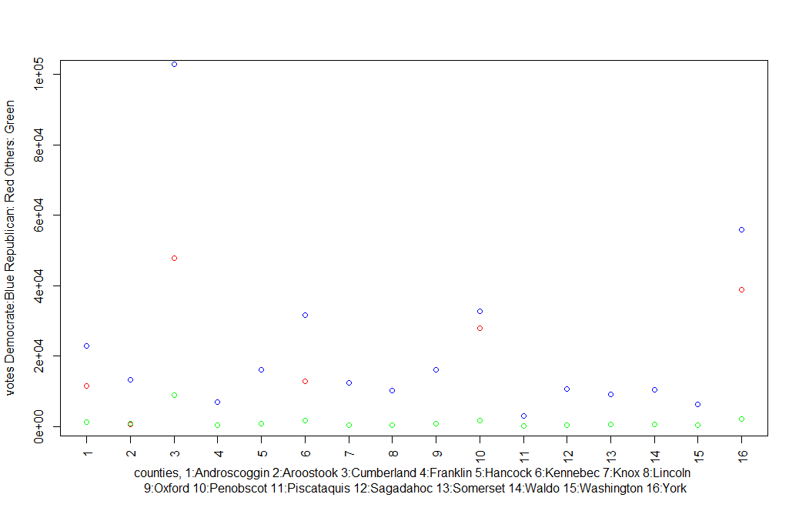

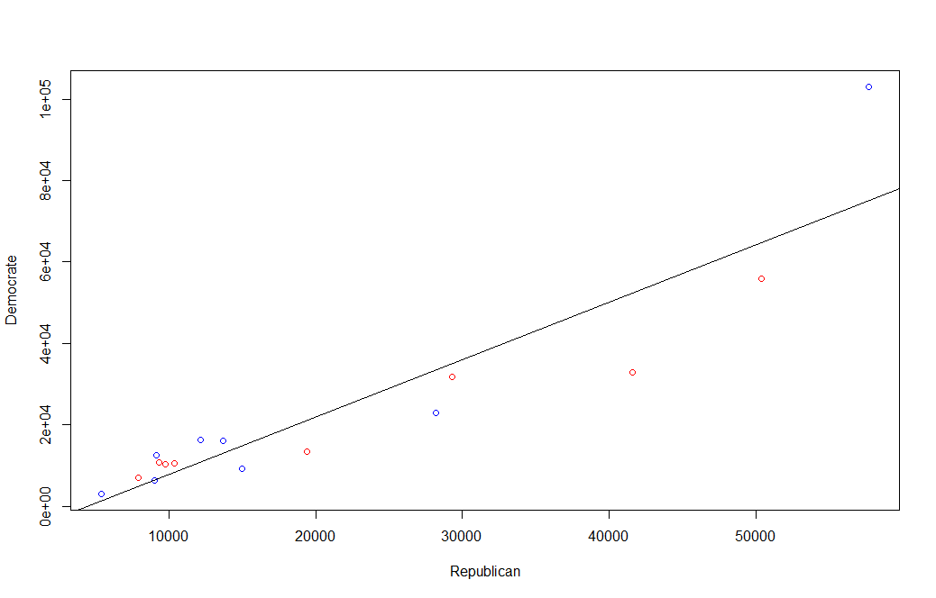

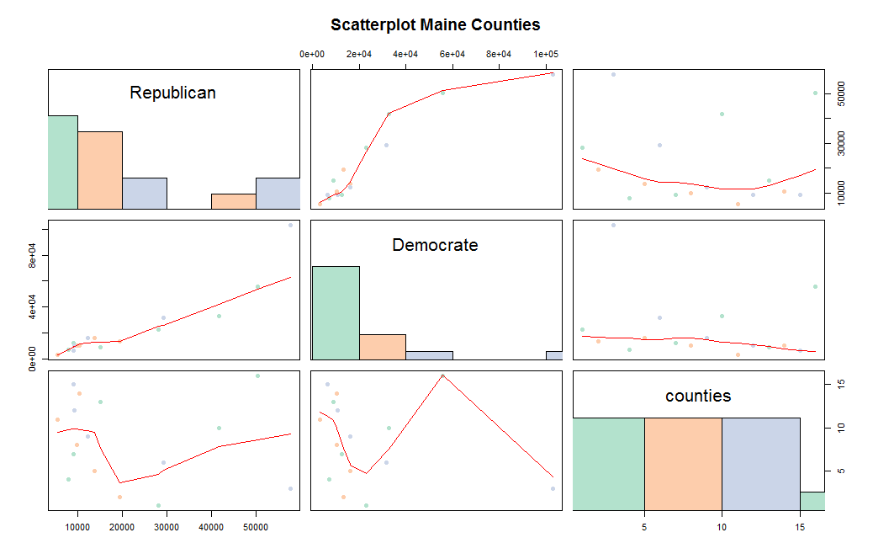

Appendix

|  |  |  |
| --- | --- | --- |
| CountyID | year | D |
| 1 | 2016 | 0.4138 |
| 1 | 2012 | 0.55 |
| 1 | 2008 | 0.5655 |
| 1 | 2004 | 0.544 |
| 1 | 2000 | 0.533 |
| 1 | 1996 | 0.566 |
| 2 | 2016 | 0.3814 |
| 2 | 2012 | 0.527 |
| 2 | 2008 | 0.5375 |
| 2 | 2004 | 0.519 |
| 2 | 2000 | 0.489 |
| 2 | 1996 | 0.518 |
| 3 | 2016 | 0.5994 |
| 3 | 2012 | 0.605 |
| 3 | 2008 | 0.641 |
| 3 | 2004 | 0.582 |
| 3 | 2000 | 0.52 |
| 3 | 1996 | 0.536 |
| 4 | 2016 | 0.4255 |
| 4 | 2012 | 0.577 |
| 4 | 2008 | 0.5887 |
| 4 | 2004 | 0.548 |
| 4 | 2000 | 0.492 |
| 4 | 1996 | 0.532 |
| 5 | 2016 | 0.5016 |
| 5 | 2012 | 0.57 |
| 5 | 2008 | 0.5874 |
| 5 | 2004 | 0.545 |
| 5 | 2000 | 0.454 |
| 5 | 1996 | 0.463 |
| 6 | 2016 | 0.4426 |
| 6 | 2012 | 0.554 |
| 6 | 2008 | 0.5643 |
| 6 | 2004 | 0.533 |
| 6 | 2000 | 0.53 |
| 6 | 1996 | 0.544 |
| 7 | 2016 | 0.5376 |
| 7 | 2012 | 0.601 |
| 7 | 2008 | 0.5974 |
| 7 | 2004 | 0.546 |
| 7 | 2000 | 0.461 |
| 7 | 1996 | 0.468 |
| 8 | 2016 | 0.4763 |
| 8 | 2012 | 0.547 |
| 8 | 2008 | 0.5507 |
| 8 | 2004 | 0.513 |
| 8 | 2000 | 0.439 |
| 8 | 1996 | 0.447 |
| 9 | 2016 | 0.3901 |
| 9 | 2012 | 0.559 |
| 9 | 2008 | 0.5668 |
| 9 | 2004 | 0.527 |
| 9 | 2000 | 0.496 |
| 9 | 1996 | 0.52 |
| 10 | 2016 | 0.4077 |
| 10 | 2012 | 0.503 |
| 10 | 2008 | 0.5172 |
| 10 | 2004 | 0.492 |
| 10 | 2000 | 0.449 |
| 10 | 1996 | 0.51 |
| 11 | 2016 | 0.3374 |
| 11 | 2012 | 0.509 |
| 11 | 2008 | 0.5072 |
| 11 | 2004 | 0.444 |
| 11 | 2000 | 0.405 |
| 11 | 1996 | 0.487 |
| 12 | 2016 | 0.4933 |
| 12 | 2012 | 0.57 |
| 12 | 2008 | 0.5705 |
| 12 | 2004 | 0.527 |
| 12 | 2000 | 0.48 |
| 12 | 1996 | 0.497 |
| 13 | 2016 | 0.3488 |
| 13 | 2012 | 0.494 |
| 13 | 2008 | 0.5177 |
| 13 | 2004 | 0.5 |
| 13 | 2000 | 0.482 |
| 13 | 1996 | 0.509 |
| 14 | 2016 | 0.4598 |
| 14 | 2012 | 0.538 |
| 14 | 2008 | 0.5477 |
| 14 | 2004 | 0.518 |
| 14 | 2000 | 0.443 |
| 14 | 1996 | 0.464 |
| 15 | 2016 | 0.3712 |
| 15 | 2012 | 0.495 |
| 15 | 2008 | 0.4951 |
| 15 | 2004 | 0.485 |
| 15 | 2000 | 0.427 |
| 15 | 1996 | 0.474 |
| 16 | 2016 | 0.4887 |
| 16 | 2012 | 0.571 |
| 16 | 2008 | 0.5936 |
| 16 | 2004 | 0.533 |
| 16 | 2000 | 0.493 |
| 16 | 1996 | 0.51 |

Where the counties are as follows:

|  |  |
| --- | --- |
| 1 | Androscoggin |
| 2 | Aroostook |
| 3 | Cumberland |
| 4 | Franklin |
| 5 | Hancock |
| 6 | Kennebec |
| 7 | Knox |
| 8 | Lincoln |
| 9 | Oxford |
| 10 | Penobscot |
| 11 | Piscataquis |
| 12 | Sagadahoc |
| 13 | Somerset |
| 14 | Waldo |
| 15 | Washington |
| 16 | York |

|  |  |  |  |  |
| --- | --- | --- | --- | --- |
| Year | D | D% | R | R% |
| 2016 | **357,735** | **47.80%** | 335,593 | 44.90% |
| 2012 | **401,306** | **56.27%** | 292,276 | 40.98% |
| 2008 | **421,923** | **57.71%** | 295,273 | 40.38% |
| 2004 | **396,842** | **53.57%** | 330,201 | 44.58% |
| 2000 | **319,951** | **49.10%** | 286,616 | 44.00% |
| 1996 | **312,788** | **51.60%** | 186,378 | 30.80% |
| 1992 | **263,420** | **38.80%** | 206,820 | 30.40% |
| 1988 | 243,569 | 43.90% | **307,131** | **55.30%** |
| 1984 | 214,515 | 38.80% | **336,500** | **60.80%** |
| 1980 | 220,974 | 42.30% | **238,522** | **45.60%** |
| 1976 | 232,279 | 48.07% | **236,320** | **48.91%** |
| 1972 | 160,584 | 38.50% | **256,458** | **61.50%** |
| 1968 | **217,312** | **55.30%** | 169,254 | 43.10% |
| 1964 | **62,264** | **68.84%** | 118,701 | 31.16% |
| 1960 | **181,159** | **42.95%** | 240,608 | 57.05% |

|  |  |  |  |  |  |  |  |  |  |  |  |  |
| --- | --- | --- | --- | --- | --- | --- | --- | --- | --- | --- | --- | --- |
|  |  | **2004** |  |  | **2008** |  |  | **2012** |  |  | **2016** |  |
|  | **D** | **R** | **O** | **D** | **R** | **O** | **D** | **R** | **O** | **D** | **R** | **O** |
| **Voter Turn Out** | **396,842** | 330,201 | 8,069 | **421,923** | 295,273 | 10,636 | **401,306** | 292,276 | 9,352 | **357,735** | 335,593 | 38,105 |
| **%** | **53.57%** | 44.58% | 1.09% | **57.71%** | 40.38% | 1.45% | **56.27%** | 40.98% | 1.31% | **47.80%** | 44.90% | 5.10% |
|  |  |  |  |  |  |  |  |  |  |  |  |  |
| **18 to 24** | 48% | 50% | 1% | 71% | 26% | 3% | 65% | 30% |  | 50% | 42% | 5% |
| **25 to 29** | 48% | 50% | 1% | 62% | 36% | 2% | 60% | 35% |  | 46% | 44% | 8% |
| **30 to 39** | 48% | 50% | 1% | 60% | 38% | 2% | 59% | 36% |  | 40% | 50% | 7% |
| **40 to 49** | 59% | 39% | 1% | 54% | 44% | 2% | 51% | 44% |  | 48% | 46% | 6% |
| **50 to 64** | 59% | 39% | 1% | 61% | 36% | 3% | 58% | 40% |  | 47% | 48% | 4% |
| **65+** | 54% | 45% | 1% | 45% | 53% | 2% | 55% | 43% |  | 56% | 39% | 3% |
|  |  |  |  |  |  |  |  |  |  |  |  |  |
| **Male** | 48% | 49% | 1% | 52% | 46% | 2% | 50% | 46% |  | 41% | 52% | 6% |
| **Female** | 57% | 42% | 1% | 64% | 34% | 2% | 64% | 34% |  | 55% | 39% | 5% |
|  |  |  |  |  |  |  |  |  |  |  |  |  |
| **White** | 53% | 45% | 11% | 58% | 40% | 2% | 57% | 40% |  | 47% | 46% | 5% |
| **Non-White** |  |  |  |  |  |  |  |  |  | 56% | 33% | 10% |
|  |  |  |  |  |  |  |  |  |  |  |  |  |
| **Total** | 824000 | | | 801000 | | | 787000 | | | 1056410 | | |